New Hope
United Methodist Church
April 4, 2021 Easter Sunday
We are New Hope United Methodist Church, a Community of Faith that exists for the Glory of God to reach out and welcome people, serve others and equip them with a faith that works in everyday life.

PRELUDE
LIGHTING OF THE CANDLES & RINGING OF BELLS
ANNOUNCEMENTS, GREETINGS, AND RECOGNITION OF GUESTS – Worship Leader
(*INVITES CONGREGATION TO STAND)

*Call to Worship (responsively):
God of birth and death and resurrection, we come because your love is calling us.
Alleluia!
Christ lives among us, an ever-present promise of transforming faith.
Alleluia!
Christ lives within us, calling us to shake up our dreams, to reach for new beginnings.
Alleluia!
Christ is risen!
Christ is risen indeed! Alleluia!

*Opening Hymn 302, Blue Hymnal
“Christ the Lord is Risen Today (vs 1-4)

Opening Prayer (in unison): Holy Jesus, we hear God’s mighty “Yes!” in Your Resurrection. You invite us to live also, and we want to say “Yes!” to you. Take us out of the tombs that imprison us. Lead us into the morning of new life, and walk with us wherever Your love may lead. In the name of the risen Christ we pray. Amen.

Special Music by Kim Thimmig & Jon Sommer
“Jesus, Keep Me Near The Cross”

Psalm Lesson Psalm 118:1-2, 14-24 (OT p. 534)
Gospel Lesson John 20:1-18 (NT p. 108)

Hymn (track 7) 364, Blue Hymnal
“Because He Lives” (verses 2 & 3)

Sermon “Sunday’s Coming!” Pastor Ric

Hymn (track 11) 377, Blue Hymnal
“It Is Well With My Soul” (vs 1 & 4)

Sharing of Joys and Concerns
Pastoral Prayer and The Lord’s Prayer
Our Father, who art in heaven, hallowed be thy name. Thy kingdom come, thy will be done, on earth as it is in heaven. Give us this day our daily bread. And forgive us our trespasses as we forgive those who trespass against us. And lead us not into temptation but deliver us from evil. For thine is the kingdom, and the power, and the glory, forever. AMEN

Invitation to the Offering
We are witnesses to the power of the Holy Spirit and the glory of God, and now we turn in thanksgiving to share the good news of forgiveness and grace to all the world. Let these our gifts be a living testimony to those who most need the healing grace of Christ this morning. Let us receive our offering.

*Doxology 302, Blue Hymnal
“Christ the Lord is Risen Today” (vs 5)

*Prayer of Thanksgiving (in unison): Generous and surprising God, when we thought that death had claimed your only Son, you amazed us with the resurrection. Surprise us again with your ability to turn these offerings into gifts that will transform the world through our witness to your love. Use us to proclaim and embody the good news of Your love. Amen.

*Closing Hymn (track 12) insert
“Hallelujah Chorus”

*Benediction
Alleluia! This is a day of new beginnings!
This is the day of brightness and hope!
For God has done wondrous things for us!
Go in joyful peace and know that God’s peace and love go with you always.
ALLELUIA! Amen.

Thank you for worshipping with us today!

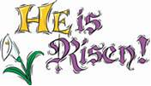
New Hope
United Methodist Church
W7797 Center Road, Glenbeulah, WI 53023-1508
Worship at 9:30 am – April 4, 2021

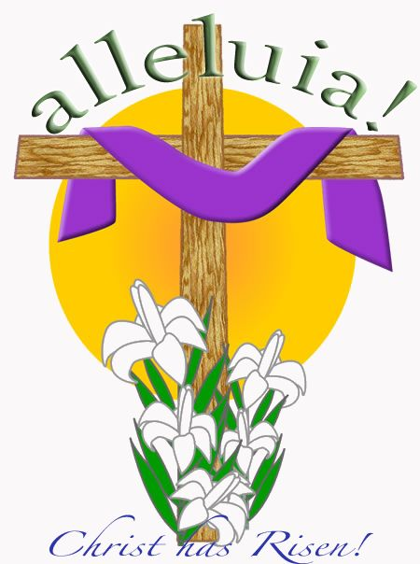

Pastor: Ric Olson pastor@gbnewhopeumc.org (920) 980-8302
If you are in need of pastoral care, please call the pastor, or call the New Hope Church Office at 920-526-3372.

Welcome to New Hope United Methodist Church
Church Phone: 920-526-3372
Church e-mail address: newhopeumc@gbnewhopeumc.org
Attendance on 3/28: 16 Offering: $ $1,150.00

ANNOUNCEMENTS:
Send announcements to: Nancy at nancy@gbnewhopeumc.org
Prayer Chain Requests: Please call Kaye Hau (920-526-3882)
Next Administrative Board Meeting: Monday, Apr 12th @ 6:30 PM
Next Communion Sunday: May 2nd
FYI: All loose coins and single dollar bills will be given to missions.

UPCOMING EVENTS:
- Today is EASTER!
- April 18th is Native American Ministries Sunday. We have a special offering and special speaker. Pastor Ric is on vacation.
- April 25th – we celebrate a baptism.

KEEP THEM IN YOUR PRAYERS:
- Prayers for all the front-line workers and prayers for all experiencing stress and anxiety as the Covid pandemic continues.
- Prayers for all school systems that are making decisions about how to open their schools safely, and the teachers, staff, parents and students who are trying to make decisions about what to do.

REMINDERS
- Thank you to all who placed an order for Easter Flowers! You are welcome to pick your flowers up after the service today!

Hallelujah Chorus

Hallelujah! Hallelujah! Hallelujah! Hallelujah! Hallelujah!
Hallelujah! Hallelujah! Hallelujah! Hallelujah! Hallelujah!

For the Lord God Omnipotent reigneth
Hallelujah! Hallelujah! Hallelujah! Hallelujah!
For the Lord God omnipotent reigneth
Hallelujah! Hallelujah! Hallelujah! Hallelujah!
Hallelujah! Hallelujah! Hallelujah! Hallelujah! Hallelujah!
Hallelujah! Hallelujah! Hallelujah! Hallelujah! Hallelujah!
Hallelujah! Hallelujah! Hallelujah! Hallelujah! Hallelujah!

The kingdom of this world
Is become the kingdom of our Lord
And of His Christ, and of His Christ
And He shall reign for ever and ever
And He shall reign for ever and ever
And He shall reign for ever and ever
For ever and ever, forever and ever

(over)

King of kings (Forever and ever Hallelujah! Hallelujah!)
And Lord of lords (Forever and ever Hallelujah! Hallelujah!)
King of kings (Forever and ever Hallelujah! Hallelujah!)
And Lord of lords (Forever and ever Hallelujah! Hallelujah!)
King of kings (Forever and ever Hallelujah! Hallelujah!)
And Lord of lords (King of kings and Lord of lords)
And He shall reign
And He shall reign
And He shall reign forever and ever
King of kings (Forever and ever)
And Lord of lords (Hallelujah! Hallelujah!)
And He shall reign forever forever and ever
King of kings! and Lord of lords!
King of kings! and Lord of lords!
And He shall reign forever and ever
Forever and ever
Forever and ever
Hallelujah! Hallelujah!
Hallelujah! Hallelujah!
Hallelujah!

